CBUS NAC Control Freak® eDIDIO Library

Firmware Version – 1.1.0

Date – 2/9/24

**Introduction**

This document outlines the CBUS NAC Control Freak® eDIDIO Lua library. This guide shows how to use the library to control DALI and DMX interfaces via TCP/IP.

**Hardware Considerations**

The eDIDIO controller must be connected to a 24V power supply. It must be on the same network as the CBUS NAC. Appropriate network settings must be configured to allow a TCP connection between the NAC device and the eDIDIO controller.

If the eDIDIO controller has DALI, it must have a suitable DALI PSU to control the lines. The DALI line(s) should be addressed and grouped as necessary. We suggest the Control Freak UBi DALI PSU. An example 1D1X is shown below.

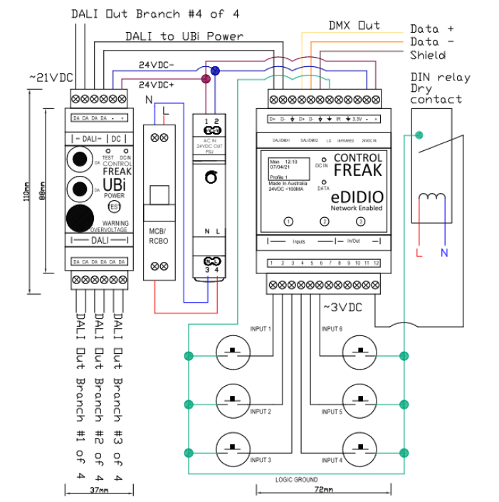

The eDIDIO can be ordered in a multiple of configurations. 1D1X refers to DALI | DMX. 2D is DALI | DALI.

A 4-line unit is also available

## 5500NAC Configuration

* Log into the 5500NAC Configuration. This can be done by entering the units IP address into a browser.
* Click on Configurator
* Navigate to Scripting -> Tools and press Restore Scripts
* Open the eDIDIO Scripting Library provided.

## Lua Functions

The library includes several functions for DALI and DMX commands, as well as enumerations for ease of use.

### Enumeration

* DALI_0 to DALI_63
* DALI_G0 to DALI_G15
* DALI_BROADCAST
* DALI Type 8
  + SET_TEMP_X_COORD
  + SET_TEMP_Y_COORD
  + ACTIVATE
  + SET_TEMP_COLOUR_TEMP
  + COLOUR_TEMP_COOLER
  + COLOUR_TEMO_WARMER
* DALI Fade
  + DALI_NO_FADE
  + DALI_0_7s_FADE
  + DALI_1_0s_FADE
  + DALI_1_4s_FADE
  + DALI_2_0s_FADE
  + DALI_2_8s_FADE
  + DALI_4_0s_FADE
  + DALI_5_7s_FADE
  + DALI_8_0s_FADE
  + DALI_11_3s_FADE
  + DALI_16_0s_FADE
  + DALI_22_6s_FADE
  + DALI_32_0s_FADE
  + DALI_45_3s_FADE
  + DALI_64_0s_FADE
  + DALI_90_5s_FADE

TriggerType

DALI_ARC = 0 -- For controlling DALI Arc Levels (0 to 254) and 255 for MASK

DALI_COMMAND = 1

DMX_CHANNELS_SPLIT_LOW = 2 -- NOTE: Expects the channel number (not zero-based)

DMX_CHANNELS_SPLIT_HIGH = 3 -- NOTE: Expects the channel number (not zero-based)

DMX_MULTICAST_CHANNELS_SPLIT_LOW = 4 -- NOTE: Expects the channel INDEX to start from, as it takes into account the start address set from Spektra

DMX_MULTICAST_CHANNELS_SPLIT_HIGH = 5 -- NOTE: Expects the channel INDEX to start from, as it takes into account the start address set from Spektra

DMX_BROADCAST = 6 -- Affects all DMX lights as per the Spektra Settings (number of lights and channels per light)

DIDIO = 7 -- DEPRECATED

FADE_UP_WITH_MIN = 8 -- DALI Fade Up Command - Query level and set Minimum if Off

LIST_START = 9 -- Start a List action once

LIST_START_CONTINUOUS = 10 -- Start a List action with repeat

LIST_STOP = 11 -- Stop a List

SPEKTRA_START_SEQ = 12 -- Start a Spektra Sequence

SPEKTRA_STOP_SEQ = 13 -- Stop a playing Spektra Sequence

SPEKTRA_THEME = 14 -- Apply a Spektra Theme

SPEKTRA_STATIC = 15 -- DEPRECATED

SPEKTRA_SCHEDULE = 16 -- Start the scheduled Spektra item

LINK_START = 17 -- Enables the UDP Link State - If Configured

LINK_STOP = 18 -- Temporarily disables the UDP Link State

DISABLE_BURN = 19 -- Disable Burn-In

ENABLE_BURN = 20 -- Enable Burn-In

ON_OFF_TOG = 21 -- Turn a Group/Addres On/Off based on query level. If DALI_GROUP_ALL, toggle based on flag

MIN_MAX_TOG = 22 -- On/Off Toggle replaced by Min/Max

ENABLE_INPUT = 23 -- Enable Input - If latching, Input will trigger immediatly

DISABLE_INPUT = 24 -- Disable Input

ENABLE_TOG_INPUT = 25 -- Toggle Enable/Disable Input

OUTPUT_TOG = 26 -- Toggle Output State between High (~22Vdc) and Low (0Vdc)

OUTPUT_HIGH = 27 -- Set Output HIGH

OUTPUT_LOW = 28 -- Set Output LOW

OUTPUT_TRIG = 29 -- Set Output to trigger momentarily based on configuration

PROFILE_CHANGE = 30 -- Change Profile - This action will reset sensor state

FADE_LONG_PRESS = 31 -- Long Press Fade based on Toggle Flag

SYNCRO = 32 -- Command sets clock to 11:59PM. Used for hardware time update by external Timeclock

PRESET_CODE = 33 -- Preset Code - See Configurator Description

CUSTOM_CODE = 34 -- Project Specific Custom Code - Talk to Creative Lighting for support

SPEKTRA_SLEEP = 35 -- Pause Spektra sequence

SPEKTRA_RESUME = 36 -- Resume Spektra sequence

DEVICE_RESET = 37 -- Admin Command for Hardware Reset

DEVICE_SAVE = 38 -- Admin Command for manual device memory save

USER_LEVEL_STORE_NEW = 39 -- Store Current Level to Variable

USER_LEVEL_SET_DEFAULT = 40 -- Reset User Level Variable

USER_LEVEL_RECALL = 41 -- Recall User Level Variable

ROOM_JOIN = 43 -- DEPRECATED

ROOM_UNJOIN = 44 -- DEPRECATED

TYPE8_TC_WARMER = 45 -- DALI Type 8 Warmer Command. 1 Mirek increments

TYPE8_TC_COOLER = 46 -- DALI Type 8 Cooler Command. 1 Mirek increments

TYPE8_TC_ACTUAL = 47 -- DALI Type 8 Set Colour to Mirek value

LOGIC_OPERATION = 48 -- Not Implemented

ALARM_ENABLE = 49 -- Enable Alarm at Index

ALARM_DISABLE = 50 -- Disable Alarm at Index

DALI_CONTROL_SENSOR_OVERRIDE = 51 -- Puts the DALI Sensor in 'override mode', which means it will no longer control the lighting until occupancy has timed-out or control is manually resumed

DALI_CONTROL_SENSOR_TEMP_DISABLE = 52 -- Sets the occupancy timer to zero and puts the DALI Sensor in a temporary 'disable mode' (duration depends on Sensor configuration: 'Disable Period')

DALI_CONTROL_SENSOR_RESUME = 53 -- Takes the DALI Sensor out of 'override mode'

DALI_ARC_OVERRIDE = 54 -- For controlling DALI Arc Levels (0 to 254) and 255 for MASK - Sets associated group to override mode

DALI_COMMAND_OVERRIDE = 55 -- For sending DALI commands - Sets associated group to override mode

FADE_UP_WITH_MIN_OVERRIDE = 56 -- Non-native DALI command override (sets associated group to override mode)

ON_OFF_TOG_OVERRIDE = 57 -- Non-native DALI command override (sets associated group to override mode)

MIN_MAX_TOG_OVERRIDE = 58 -- Non-native DALI command override (sets associated group to override mode)

MAX_OFF_TOG = 59 -- Not Implemented

MAX_OFF_TOG_OVERRIDE = 60 -- Not Implemented

FADE_LONG_PRESS_OVERRIDE = 61 -- Non-native DALI command override (sets associated group to override mode)

USER_LEVEL_RECALL_OVERRIDE = 62 -- Non-native DALI command override (sets associated group to override mode)

DMX_ZONE_FADE_UP = 63 -- DMX Spektra Zone Fade UP

DMX_ZONE_FADE_DOWN = 64 -- DMX Spektra Zone Fade DOWN

LOGGING_LEVEL = 65 -- Enable Logging to EEPROM to be read by configurator

SPEKTRA_SHOW_CONTROL = 66 -- DEPRECATED

CIRCADIAN_TEMPERATURE = 67 -- Selects Colour Temperature based on clock

DALI_CONTROL_SENSOR_MUTE = 68 -- Mute Sensor at Index (or all with Index 255)

DALI_CONTROL_SENSOR_UNMUTE = 69 -- Unmute to Sensor at Index (or all with Index 255)

SPEKTRA_INTENSITY = 70 -- Allow you to specify the maximum Spektra Sequence or Theme output intensity (10 to 100)%

ENABLE_INPUT_NO_ACTION = 71 -- Allow you to enable an input (Latching), but not trigger the action.

SET_DALI_FADE_TIME = 72 -- Sets the DALI Fade Time

NO_COMMAND = 254 -- This TriggerType should always be at the bottom of the list. Add any new TriggerTypes above it (up to 253).

### Functions

|  |  |
| --- | --- |
| **Function** | **Command** |
| Sends 3 DALI Levels to an RGB fixture | sendDALIRGBMessage(line, address, red, green, blue) |
| Converts RGB to XY Coordinates for DALI DT8 | sendDALIRGBDT8Message(line, address, red, green, blue, brightness) |
| Converts Kelvin to Mirek and outputs DALI CCT DT8 | sendDALICCTDT8Message(line, address, kelvin, brightness) |
| Send a DALI Level (0-254) | flag = sendDALIArcLevel(line, address, level) |
| Set the DALI fixtures to a specific fade (See Enums) | flag = sendDALIFadeMessage(line, address, fadetime) |
| Sends a specific DT8 Command | flag = sendDT8Cmd(line, address, cmd, arg) |
| Get DALI Level (0 to 254) | flag, level = getDALILevel(line, address) |
| Sends a singular DMX Level. Fade = fadetime * 10ms. Repeat for block commands | sendDMXLevel(line, channel, level, fadetime, repeat) |
| Sends a DMX RGB command. Repeat for consecutive addresses | sendDMXRGB(line, channel, red, green, blue, fadetime, repeat) |
| Sends a DMX RGBW command. Repeat for consecutive addresses | flag = sendDMXRGBW(line, channel, red, green, blue, white, fadetime, repeat) |
| Send a trigger, specified by TriggerType | flag = sendTrigger(line, zone, TriggerType, target, value, query) |

### Parameters

* Line – This depends on the installed hardware. I.e. eDIDIO 1D 1X = DALI | DMX
  + Physical Line 1 = 0x01
  + Physical Line 2 = 0x02
  + Physical Line 3 = 0x04
  + Physical Line 4 = 0x08
  + Multiple Lines (Line 1 + Line 2) = 0x01 + 0x02 = 0x03
* Address – See Enum. DALI_0 to DALI_63 + DALI_G0 to DALI_G15 + DALI_BROADCAST
* Red, Green, Blue, White, Brightness
  + For DALI, values range from 0 to 254
  + For DMX, values range from 0 to 255
* Fadetime
  + For DALI, seen Enum, DALI_0_7s_FADE = 0.7s fade
  + For DMX, total fade time = fadetime * 10ms.
* Repeat
  + Value can be 0 to Max DMX.
    - For Standard DMX, value can be 512 – channel
    - For RGB, value can be 512/3 – channel
    - For RGBW, value can be 512/4 – channel
* Flag – Success or Failed

## Library Configuration

Library Configuration is through the eDIDIOConfig script. Enter the IP of the eDIDIO.

The IP can be found through the DIDIO Configuration software, or via the keypad on the unit.

## Examples

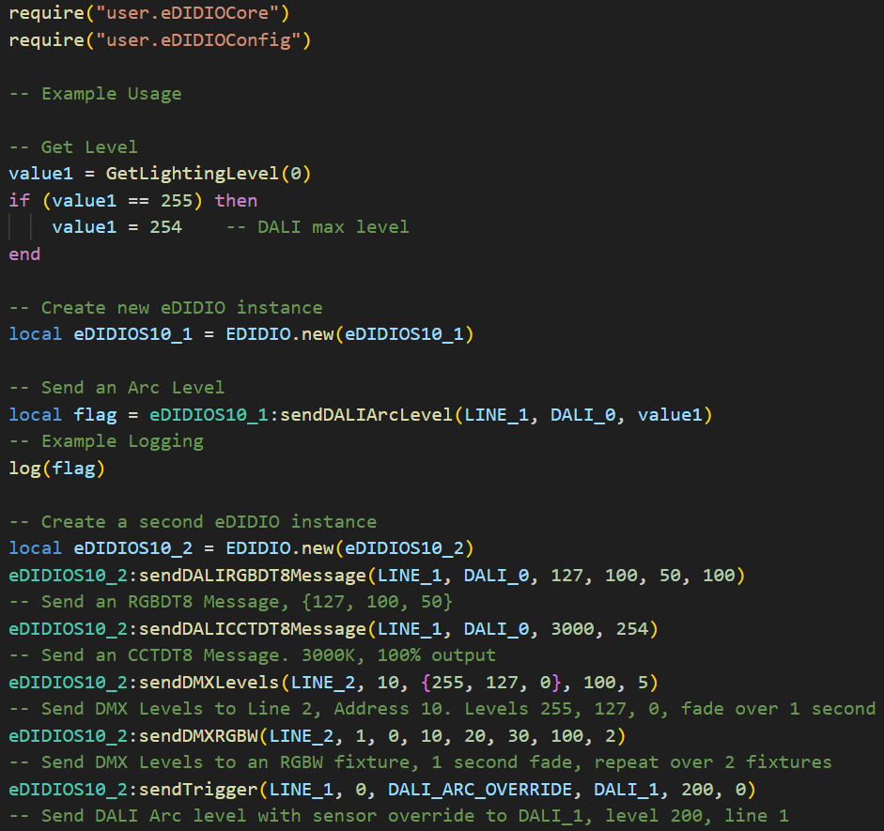

**DALI Installation**

The DALI fixtures should be configured into controllable groups. This can be done using the Control Freak DIDIO Configurator software.

<https://github.com/CreativeLightingAdmin/DIDIO-Configurator-Releases>

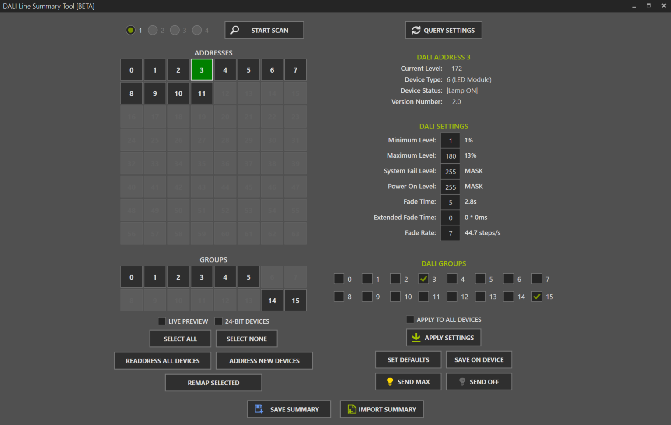

**DALI Speed**

DALI DT8 commands are slow. Please note that to change colour via DT8 can take around 11 DALI messages.